**Web Engineering**

**Project Name:** Religious Website

**Proposed by:** Hamza Shahid

**Roll No:** 20P-0117

**Wireframes:**

**Home / About / Contact us Pages:**



**Sign up page:**

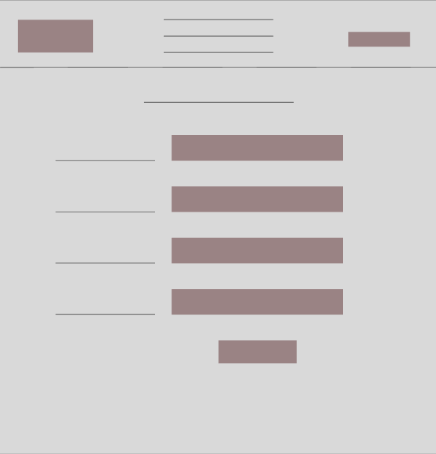

**Login page:**

